Linked-in Blog 2 – The AI EHR Sovereign Mesh Interoperability Protocol

I find it interesting that some AI EHR model and cloud providers want to be the one-stop shop for Generative and Predictive AI for Healthcare Information systems hardware and software ( IaaS, SaaS and PaaS) are all rolled up into one. Got it. Perhaps we forget the reason Open Source software and vendor choices on infrastructure hardware, networking and fabric storage exists today. Having choices does make a difference in terms of freedom from vendor lockin, prices, performance, service levels and prevents reliance on a single entity. When architects design solutions, network and security are fundamental essentials. As far as cloud provisioning, some may be fooled into believing there is no single point of failure. However, Boolean logic is simple; No network = No service. Therefore, organic presence is required for continuity of operations in cases of catastrophic failures. Just ask the trauma teams in the middle east, a Commander on a Carrier, members of a Care Team on a Hospital Ship, or a triage team in a Combat Surgical Hospital. We believe we are safe from harm and that never will our country be at the same risks in the middle east. Now is the time to prepare so that we are not caught off guard.

That is why the CIO’s and CEO’s who are doing their due diligence on choices that are made regarding architecture for resilient, zero-defect AI EHR integrations will succeed and benefit from an open architecture that is secure at every level, but also decentralized.

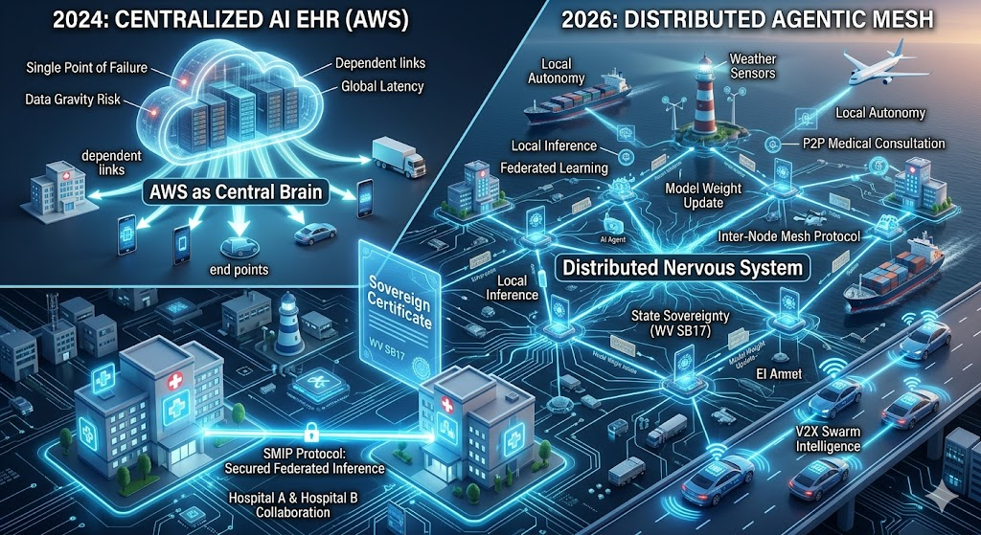
A vision of the AI EHR Neural Network for failsafe continuity of operations in Healthcare.

The Sovereign Mesh EHR is a decentralized, edge-first healthcare intelligence platform. Unlike traditional cloud-based EHRs, it utilizes the Sovereign Mesh Interoperability Protocol (SMIP) to allow hospitals and mobile end-nodes (Hospital Ships, Life Flight, Emergency Vehicles) to collaborate on first responder triage, subjective/objective assessments and clinical diagnoses without transmitting raw Protected Health Information (PHI) to a centralized cloud.

Feedback on this blog is welcomed and encouraged.

